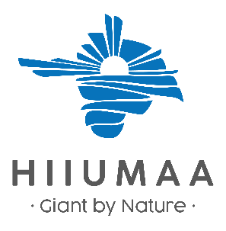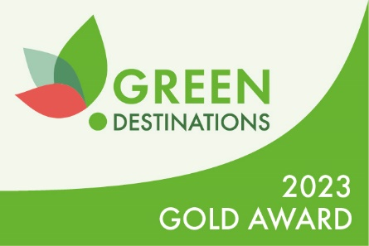
A PARADISE ISLAND IN THE BALTIC SEA,
A SPA FOR THE SOUL

Hiiumaa is a peaceful island in the Baltic Sea, covering less than 1,000 km² with a population of 9,000. Known for its unique natural and cultural heritage, it is part of the UNESCO Biosphere Programme and a Green Destinations Gold Level destination, offering a private and tranquil setting for relaxation.

Notice the Hiiu Heritage!
Notice and preserve Hiiu heritage
Hiiumaa is a place with a unique and rich cultural heritage. Here, we have our own language, folk costumes, boat types, songs, dances, and local food. You can also learn all this here!
Recognize Hiiumaa’s spirit. Care and give momentum to local production!
Ask our staff where to buy local crafts, art, food, and more!
When visiting, we recommend wearing folk costumes from your home region and sharing your heritage!

Natural Biodiversity and Cultural Heritage – a Unique Combination
You are in a rare UNESCO Biosphere Program area. Not everyone gets here!
Human activity occurs here in harmony with the natural ecosystem.
Ask a local about how to live in harmony with nature!
It’s safe on marked trails. This way, you leave a smaller footprint on nature!
Thank you for noticing and caring!
Be eco-friendly too and watch your footprint!

Hiiumaa is the Home of the Hiiu People
Respect privacy!
You are welcome in all places where signs invite and marks allow.
Let the local (in their room) be on their own!
For locals only! Want to be friends? Call first!

Sustainable Economic Development
We have a small island, but big goals. Help us achieve them by acting consciously!
We are a sustainable company and work in harmony with the environment. Help us do this, consume consciously!
We follow Fred Jüssi’s principle: “As much as necessary, as little as possible!”

Energy-Efficient and Sustainable Tourism
Electricity doesn’t come from the wall! If you’re not using it, turn it off.
You’re on an island, and every molecule of electricity counts. Consume consciously!
Charge electric vehicles in designated places!
Going out? Did you turn off the lights?
Had a sauna? Turn off the heater!
Doing nothing saves the environment.

Water
Hiiumaa’s delicious drinking water is a valuable natural resource – consume it carefully.
455 million years ago, a meteorite created the Kärdla crater, and the pure groundwater between the rock layers is pressed to the surface through artesian wells.
The tap water in Kärdla comes from the same artesian water layer, but it has undergone additional filtration and purity checks.

Washing – Towels – WC
Washing laundry uses water, energy, and chemicals. By reducing washing, we reduce the burden on the environment.
Did the bed suit you? Still sleeping? Leave this sign on the bed if the same sheets are okay for the next night!
Towel on the drying rack (or hook) = I’ll use it again. Towel on the floor (in the laundry basket) = please clean towel.
Dry towels and linens as shown in the picture.
Every paper was once a tree. Use paper sparingly.
Only toilet paper in the toilet – and the one you made yourself.
Leave the sand on the beach or wash it off outside. The shower floor doesn’t need to be sanded.

Doors – Windows
Going out? Did you close the doors and windows?
There’s air conditioning in the room. Use it as needed.
The air conditioner (AC) is working? Close the doors and windows!

Campfire and Firewood
Firewood is a natural resource, burn it according to need!
Each log produces 2 kg of CO2 when burned.
Price includes 1 basket of firewood. Need for more? Ask!

Local Food
Local organic food is fresh and healthy. And eco-friendly, as no airplanes were used in the food transportation chain.
We avoid food waste, take as much as you can eat.
Our portions are filling. If you’re counting calories, ask for a smaller portion.

Waste and Waste Management
We are on a garbage free island and have worked hard for this. Let’s continue in the same spirit!
Every piece of trash wants to reach its designated bin. You can help sort it.
Brought the packaging here? You can take it back too!

Social Responsibility and Community Cooperation
In Hiiumaa, everyone knows everyone and remembers who did what. Be polite!
Glad you came, and thank you for being friendly!
A local is still a human!
Energy-Efficient Transport
How large of a vehicle does your body need? And your ego?
Who has the most horsepower when they reach their destination?
If it’s not really necessary, skip the car ride.
Walk or ride a bike – eco-friendly and healthy.
Didn’t take your steps today? Walk or circle your car!
Add minutes to the distance signs along with the meters, with a pedestrian symbol. Example: beach --> 3 min.

Warnings / Persuasion
In the house, the house rules. By entering, you agree to follow them. If you don’t know, ask.
Something fell or broke? Inform the staff and we’ll find a solution. Dealing with damage found later is more expensive.
We don’t monitor our guests with security cameras. But the dog remembers everything.

